## **Merchant Coalesce (v2 implementation with NetSuite)**

GTM POC: Jarrett

Implementation POC: Royce

ERP: NS

Scoping start date: Jul 2, 2024

Implementation Completed Date (Go live date): Aug 21, 2024

MSA Signature Date: Feb 9, 2024

Tax Integration: No Tax

### 

### Key people at Merchant

### CFO: Nick Decesare ([nick.decesare@coalesce.io](mailto:nick.decesare@coalesce.io)) Buyer and Product Partner

### Senior Fiance: Tianna Tugulavioa ([tianna@coalesce.io](mailto:tianna@coalesce.io))

* Finance: Sylvia Hoang ([sylvia.hoang@coalesce.io](mailto:sylvia.hoang@coalesce.io))

### 

### Company summary: Coalesce helps you transform data your way, by making data transformations as efficient as possible. All so you can create quality data sets in a fraction of the time, maximize the impact of your team’s work, and take your data projects to new heights.

AE/ Implementation Manager Notes

| Nick is very bullish on Tabs. Wanted to do a 3-year contract. Believes in us and the roadmap. He’d be a great advisor.  Tianna has been the most hands-on with NetSuite building and integrations. Sylvia is new and was hire as of Jul 22, 2024.  [Tabs | Coalesce - Netsuite Implementation](https://docs.google.com/document/d/1SqdIT752cRns2FRTM7GcfU_MqaqNApW0tisZ7Ohh1D0/edit#bookmark=id.rduod1gz3s5g) |
| --- |

**Billing model**

* Info on how merchant bills: Mostly annual, multi-year contracts
* How contract is broken up: SaaS
* One-off things to know about merchant: they have international contracts

### 

### 

### Contract Processing Steps

**NEW guidance**

1. Do not process Purchase Orders
   1. Only process the Order Form sent
   2. If no Order Form found, flag to [Ashni Walia](mailto:awalia@tabsplatform.com)
   3. Add the PO# from the purchase order into the first invoice.
2. Customer creation
   1. If an existing customer exists, please select the existing customer in the garage drop down.
   2. If customer doesn’t exist, create a customer:
      1. If US and USD - please leave the toggle to show USD

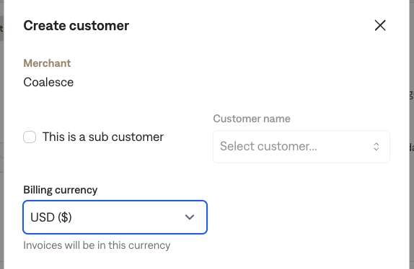

* + 1. If an international currency is listed (usually in bold next to the total) - please select that currency in the dropdown

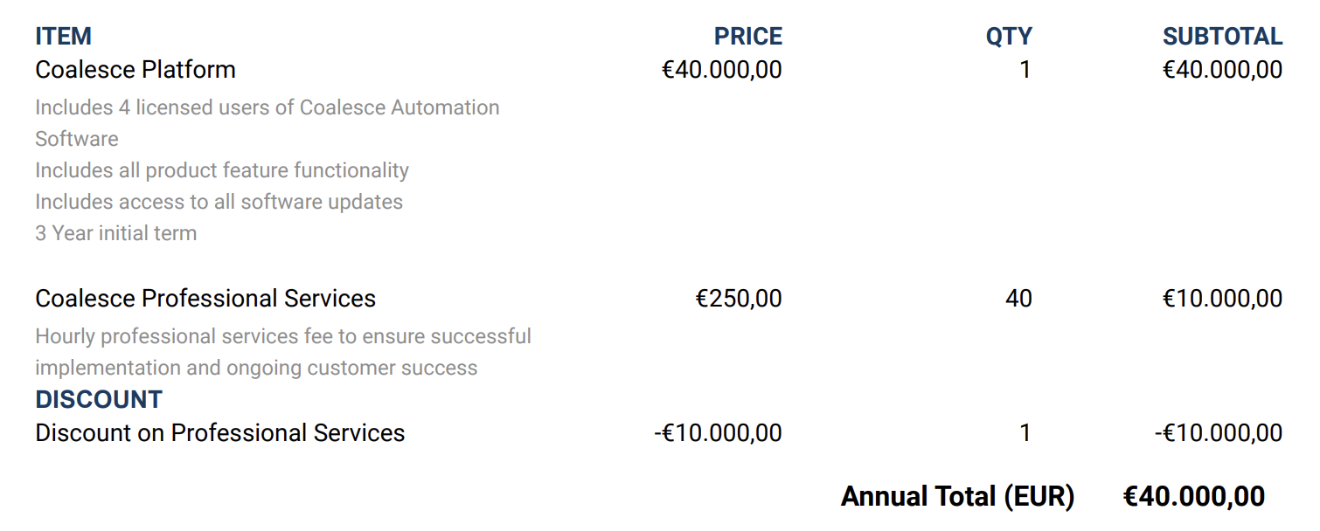

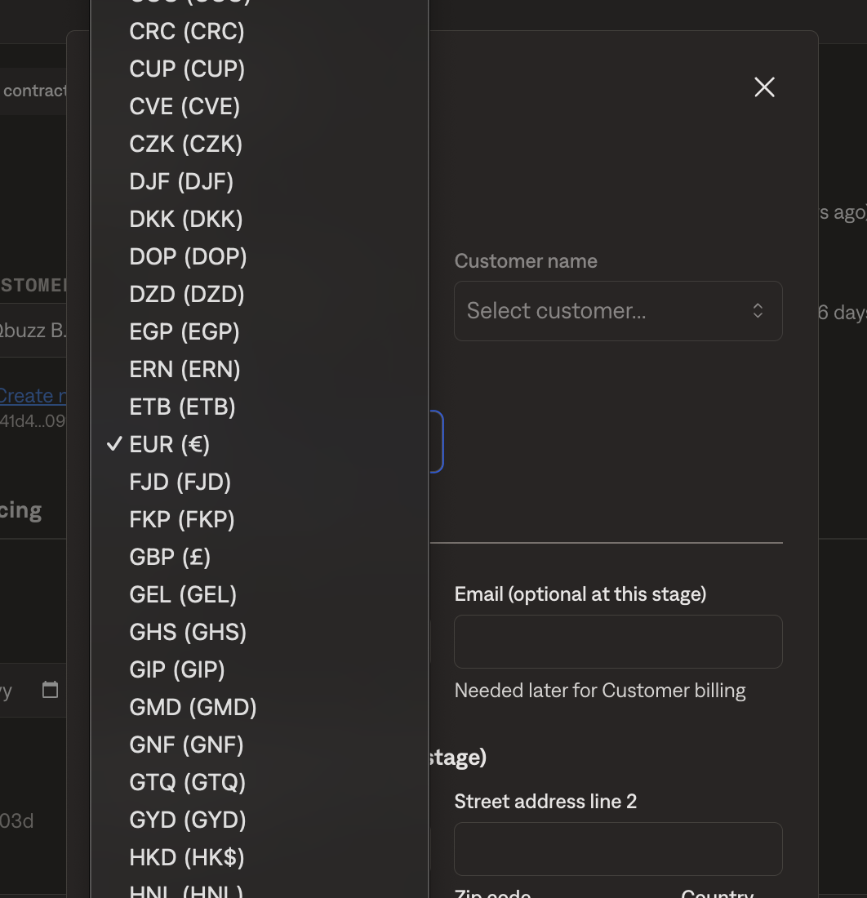

1. Look for the contract signature date (Populate this in the Key Terms “Start Date” column)
   1. Use the last signature date (ignore the docusign audit page on the last page of the contract)

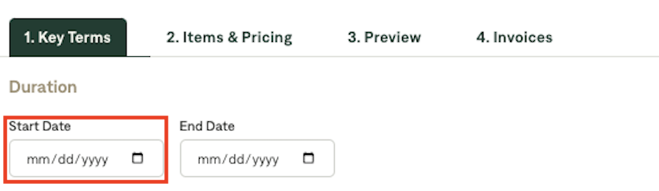

1. The instructions in the Merchant email supersede the MIS instructions.
2. Look for the items and pricing from the contracts.
3. For each multiple year line item with the same item name and quantity, create 3 revenue schedules with the same length and start date.
   1. Unless pricing is the same for each year - then you can consolidate into one BT. This contract for example would have 2 BT:
      1. One for Platform Fee, billed every year, 3x
      2. One for Silver Package, billed every year, 3x

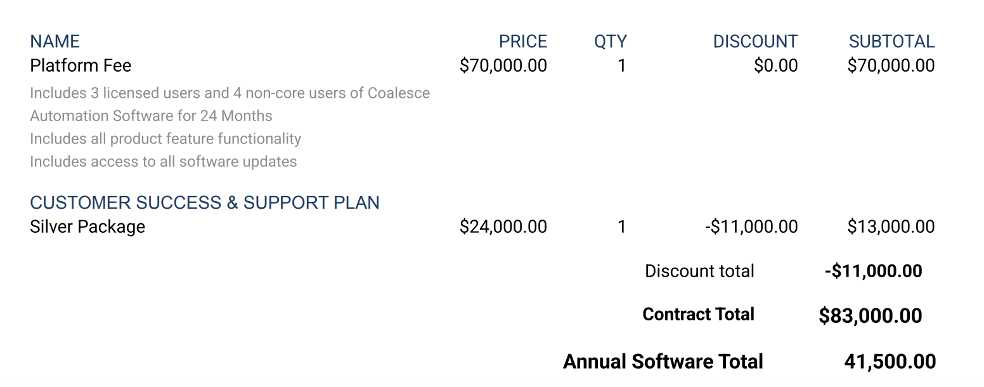

* 1. For example: A 3 year contract and the following are the billing schedule
     1. Year 1: $20,000 (discounting $5,000) = $15,000
     2. Year 2: $20,000
     3. Year 3: $20,000
        1. This will be 3 Revenue schedules of same length and start date
  2. **Service Start Date will be the subscription start date** if explicitly mentioned. If it is not mentioned, default to the last signature date.
     1. Start date: Year 1 start date
     2. Month of service will be 36

1. Item
   1. Item Name:
      1. Process Item name as displayed in the contract
      2. ~~If discount line item, name should just say discount (write as a negative BT)~~
   2. ~~Item Description: For discounting, please specify the items that it’s been discounted for in the description (e.g., Platform, Additional User License, etc)~~
   3. Please add discounts in line item going forward
2. Quantity
   1. When billing platform seats, show 1 Quantity for “Coalesce Platform”
   2. When billing all other line items, show the actual quantity in the BT’s quantity section
3. When processing Coalesce Contracts, billing start date:
   1. New Contract: Default to the last signature date. Unless explicitly stated otherwise in contract.
      1. Here’s an example - N-Able where invoice date is explicitly stated to be different from the signature dates. ([Garage link](https://garage.tabsplatform.com/prod/contracts/2aba6392-e5f0-4113-90bb-38ab8cb77bc8/terms/revenue))
      2. Another example: “use the *earliest* of service date or signature date."
         1. You would follow which is earliest here
   2. Renewals: Invoice date will always be written in renewal contract.
      1. Renewals billing starts on the day after the first term
         1. First term: 3/17/2024 - End date: 3/16/2025
         2. Renewal term: 3/17/2025
      2. For renewals, if a renewal date is missing, make best effort based on previous billing date if there is one
      3. If autorenewal included in contract, please generate an invoice
      4. **Additionally, sometimes coalesce sends renewal requests in the email body**
         1. They will attach the original contract and note the product to renew & dates of the renewal period
         2. Please check the view email body feature in garage on every contract to see if it’s a renewal (see below) but particularly if the contract pdf has dates that are from a previous year, that’s a good clue that it may be a renewal
         3. Please process renewal terms on the original contract instance



1. Here’s the detailed instructions to process **PERIOD AND FREQUENCY**
   1. This is very important as this impacts Revenue Recognition on their NetSuite instance. Please do NOT deviate from this even though there could be different ways to get to the same thing.

**ANNUAL CONTRACTS**

|  | **Periods** | **Frequency** | **No. of invoice** |
| --- | --- | --- | --- |
| 1 year | 1 | 1 YEAR | 1 |
| 2 years | 2 | 1 YEAR | 2 |
| 3 years | 3 | 1 YEAR | 3 |

**QUARTERLY CONTRACTS**

|  | **Periods** | **Frequency** | **No. of invoice** |
| --- | --- | --- | --- |
| 1 year | 4 | 3 MONTHS | 4 |
| 2 years | 8 | 3 MONTHS | 8 |
| 3 years | 12 | 3 MONTHS | 12 |

**MONTHLY CONTRACTS**

|  | **Periods** | **Frequency** | **No. of invoice** |
| --- | --- | --- | --- |
| 1 year | 12 | 1 MONTH | 12 |

1. Integration Items guidance

| **Description on contract** | **Item Mapping** |
| --- | --- |
| Coalesce Developer License  *User License*  Platform Fees  Coalesce Platform | Coalesce Platform Fee |
| Additional Coalesce Platform License | Additional Platform Licenses |
| Reseller Margin | Net Referral Fee Adjustment |
| Jumpstart | Jumpstart |
| Basic Package | Jumpstart |
| Blue Square Package | Professional Services (3 months) |
| Additional Coalesce Non Core User | Additional Platform License |
| Additional Coalesce User | Additional Platform licenses |
| Additional User License | Additional Platform licenses |
| Coalesce Professional Services | Professional Services (3 months) / Professional Services (6 months)* |
| Silver or Gold Package | Ongoing Services |
| Private Support Link | Packaged Services |

**\*For professional services, use 3 month integration by default. If explicitly stated, use 6 month integration.**

* **Professional services and jumpstart** to be in a separate **revenue schedule** with a service term of 3 months by default. If explicitly stated, use 6 months instead. Billing period to match the service term.
  + If service term starts after the 20th of month, rev schedule should start on the 1st of the following month.
* **Ongoing Services**

1. For billing contact name, default on all to ([Company Name] AP Dept)
2. No need to process rev share agreements
3. For any items that net to $0 in charges after discounts, pls make sure to add BTs. Anything on contract, should be a BT as the customer has purchased that item, possibly with a discount (up to 100%).
4. If quantity is equal to 0 then you can skip adding it as a billing term.
5. Check for PO number
6. Add PO number if a PO document has been sent or if listed in the contract itself
   1. Via invoices tab in Garage, add PO to the first invoice
   2. The PO billing schedule will supercede the contract/MSA  
      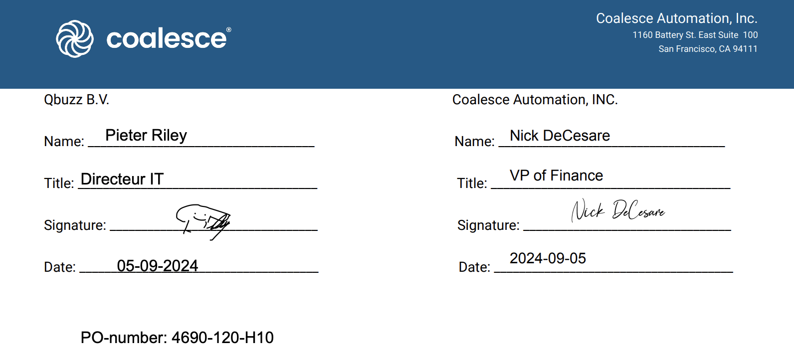
7. **Reseller fee**: Please input the subtotal as one BT and the reseller fee as a second BT with a negative value. (e.g. $1,000 subtotal with 30% reseller fee, should have 2 BTs. One for $1,000 and one for -$300) Res

Post Processing Communications (if necessary)  
*(Implementation/Success to fill)*

* **Slack-bot message**: Use the invoices tab in garage once a coalesce contract has been processed and reviewed.
  1. Please ensure slack message is sent *only* for the 1st invoice in series and **not all future invoices.**
     1. Example: If you process a 3 year contract in July 2024 with annual invoice please send slack message for July ‘24 but not for July ‘25 or ‘26

### Customer Information

* Any important information on specifics customers of this merchant
  + Special memo’s certain invoices require
  + Invoice changes due to merchant/customer relationship

### Feature Requests

* Rev Rec / Reporting
  + What is it
  + Why it's important
  + Urgency: Medium High

### Rewatch Calls

Most recent first

* <https://tabs.rewatch.com/video/8z0ppateb843jirt-tabs-coalesce-follow-up-march-6-2024>
* <https://tabs.rewatch.com/video/q2mxtoi4vt8yz6ef-coalesce-tabs-demo-march-5-2024>
* <https://tabs.rewatch.com/video/he7pbtaup7tv6k6z-coalesce-tabs-overview-february-28-2024>
* <https://tabs.rewatch.com/video/7t66meowpi7ict5w-nick-decesare-and-ali-hussain-february-2-2024>